**Introduction to Maven**

* **Maven is a build automation Tool. (It makes the project build process easier)**
* **It can be used with a lot of Programming languages such as C, C++, Java, PHP and Scala etc.**
* **Maven can be used from the command prompt or it can also be integrated with several existing Java IDEs.**

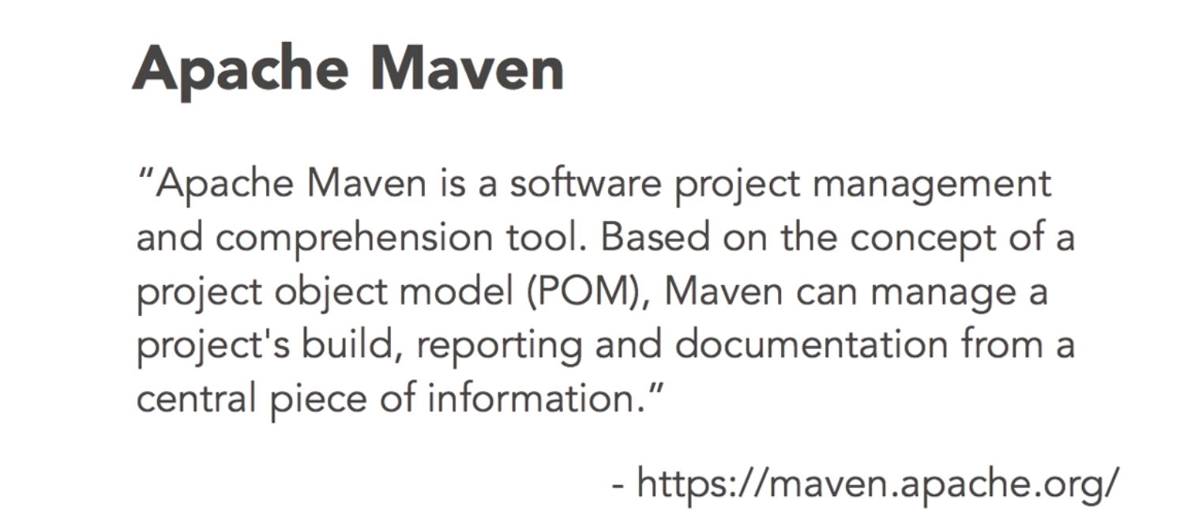

* **Maven is defined to provide simple project.**